Assignment 1

Secure Programming

B00159127 Lan Ngai, B00159763 Kai Guy

Contents

Executive Summary 4

Scope 5

Findings 6

1. Path Traversal & Arbitrary File Read 6

Impact of Path Traversal: 6

Proof of Concept: 6

Remediation Steps: 7

2. Authentication Bypass 8

3. SQL Injection 9

Impact: 9

Proof of Concept: 9

Remediation Steps: 10

4. IDOR 12

Impact: 12

Proof of Concept: 12

Remediation Steps: 12

5. Stored XSS 14

Impact: 14

Proof of Concept: 14

Remediation Steps: 15

6. Exposure of Sensitive Information 17

Impact: 17

Proof of Concept: 17

Remediation Steps: 17

7. Unmasked Password 20

Impact: 20

Proof of Concept: 20

Remediation Steps: 20

8. Resource Exhaustion 22

Conclusion 23

Statement of Contribution 24

Lan Ngai 24

Kai Guy 24

References 25

Table of Figures

Figure 1.1 - Source code showcasing path traversal vulnerability 6

Figure 1.2 - URL crafted to download the entire DB through path traversal 7

Figure 1.3 - Successful download of database due to path traversal 7

Figure 1.4 - Visiting the same URL that enabled path traversal after applying the fix 7

Figure 1.5 - The “Unauthorized access attempt” properly displays 7

Figure 3.1 - SQL injection on the login page. 9

Figure 3.2 – Profile accessed through the SQL injection 10

Figure 3.3 - Code vulnerable to SQL injections in app.py 10

Figure 3.4 - Remediation attempt made in app.py 10

Figure 3.5 - SQL injection attempt after remediation 11

Figure 3.6 - Successful remediation attempt 11

Figure 4.1 - IDOR Vulnerability – Accessing profile to that of user id no.2 12

Figure 4.2 - IDOR Remediation Code 13

Figure 5.1 - comments.html template before remediation 15

Figure 5.2 - comments.html template after remediation 15

Figure 5.3 - Comments webpage after remediation 16

Figure 5.4 - The comment section after the remediation steps 16

Figure 6.1 - Profile page before remediation attempt 17

Figure 6.2 - Functions to mask card number and expiry 18

Figure 6.3 - Masked card details 18

Figure 6.4 - Changes made in the app.py source code 19

Figure 7.1 – Login page before Remediation 20

Figure 7.2 - Changes in the source code 21

Figure 7.3 – Login page after Remediation 21

# Executive Summary

This report outlines several critical vulnerabilities discovered in the web application provided to the students. Remediation steps are provided for each vulnerability, which currently allow access to sensitive user data and other potentially sensitive and destructive abilities.

# Scope

The scope of this assessment is limited to the running application, and its source code.

# Findings

## Path Traversal & Arbitrary File Read

#### Severity:

Critical

### Impact of Path Traversal:

Path Traversal enables attackers to potentially gain access to information without authentication, this includes the sites source code, database, operating system files, etc.

In some cases, just path traversal can give an attacker enough information about a system to launch further attacks.

This obviously leads to data breaches and breaches the privacy of the users.

### Proof of Concept:

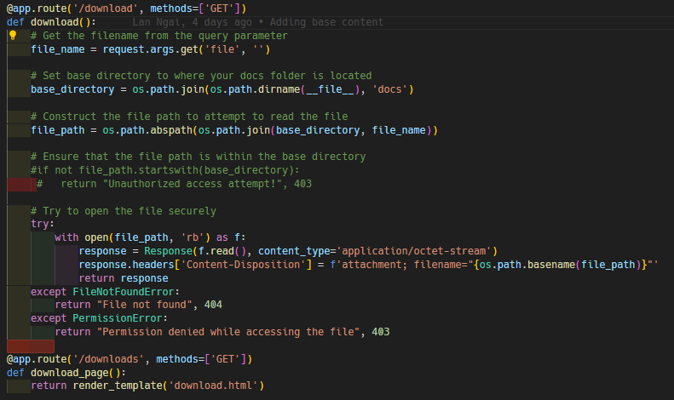

Figure . - Source code showcasing path traversal vulnerability

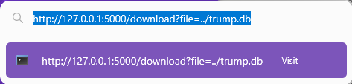

Figure . - URL crafted to download the entire DB through path traversal



Figure . - Successful download of database due to path traversal

### Remediation Steps:

The simple fix to this **CRITICAL**vulnerability is surprisingly already in the source code, however it is commented out.

To repair the vulnerability, simply uncomment the code and you will no longer be able to traverse the directory structure beyond the “docs” folder.



Figure . - Visiting the same URL that enabled path traversal after applying the fix

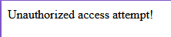

Figure . - The “Unauthorized access attempt” properly displays

## Authentication Bypass

‘/admin_panel’ shown in requests when clicking on the sitemap option on the website. That’s how that page was made known to us.

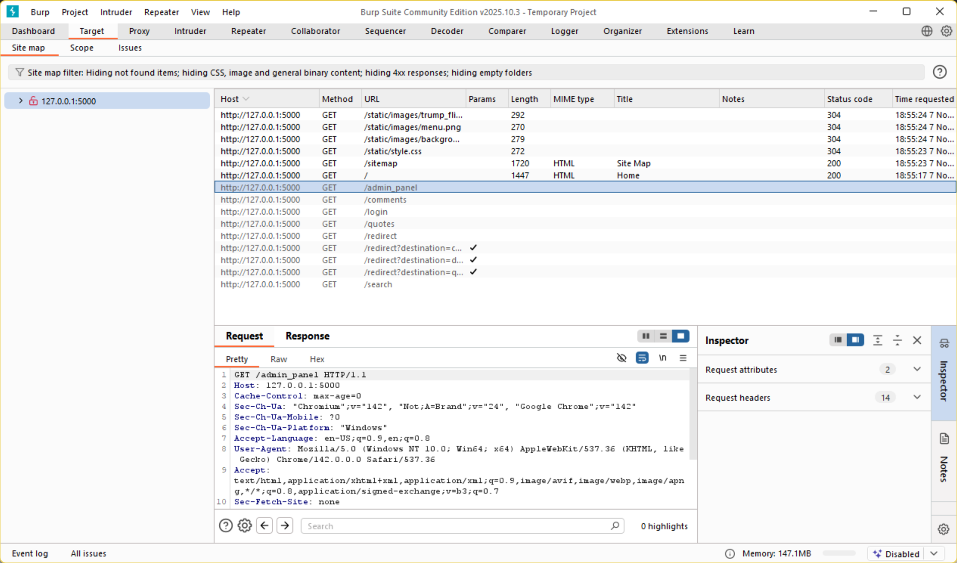

Adding ‘/admin_panel’ we get access to that page which is visible without logging in.

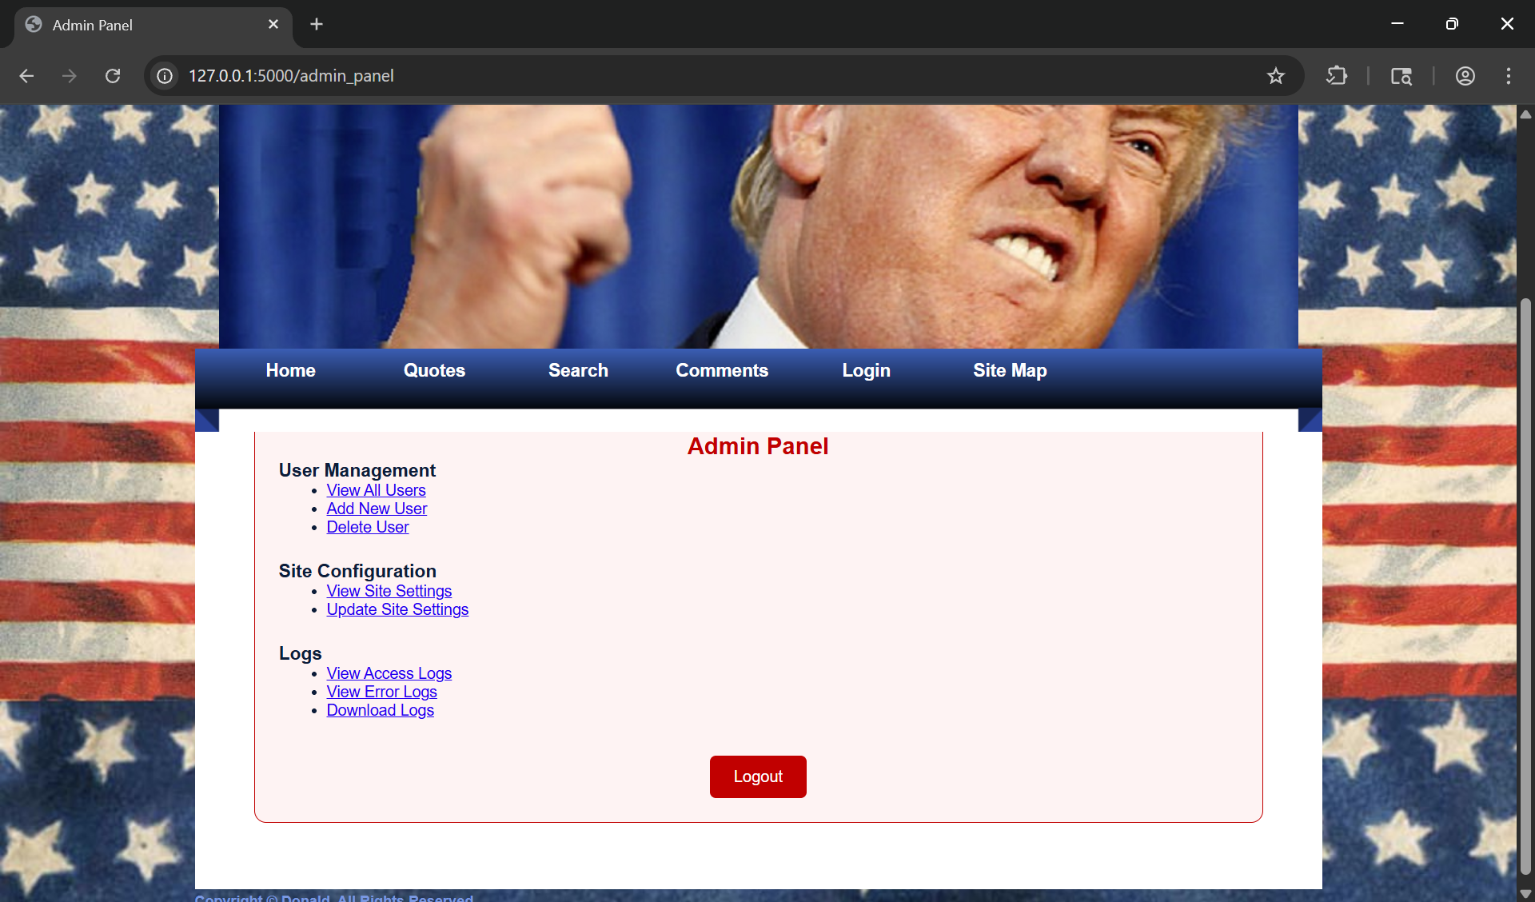

## SQL Injection

#### Severity:

High

### Impact:

The impact would include allowing an attacker to access sensitive information stored in the database as well as modifying that information.

### Proof of Concept:

In the login page by putting the following (‘OR 1=1 --) in both the username and password fields logs you in due to that being a statement which is always true. The original code allows for this exploit because it uses formatting to directly concatenate user input.

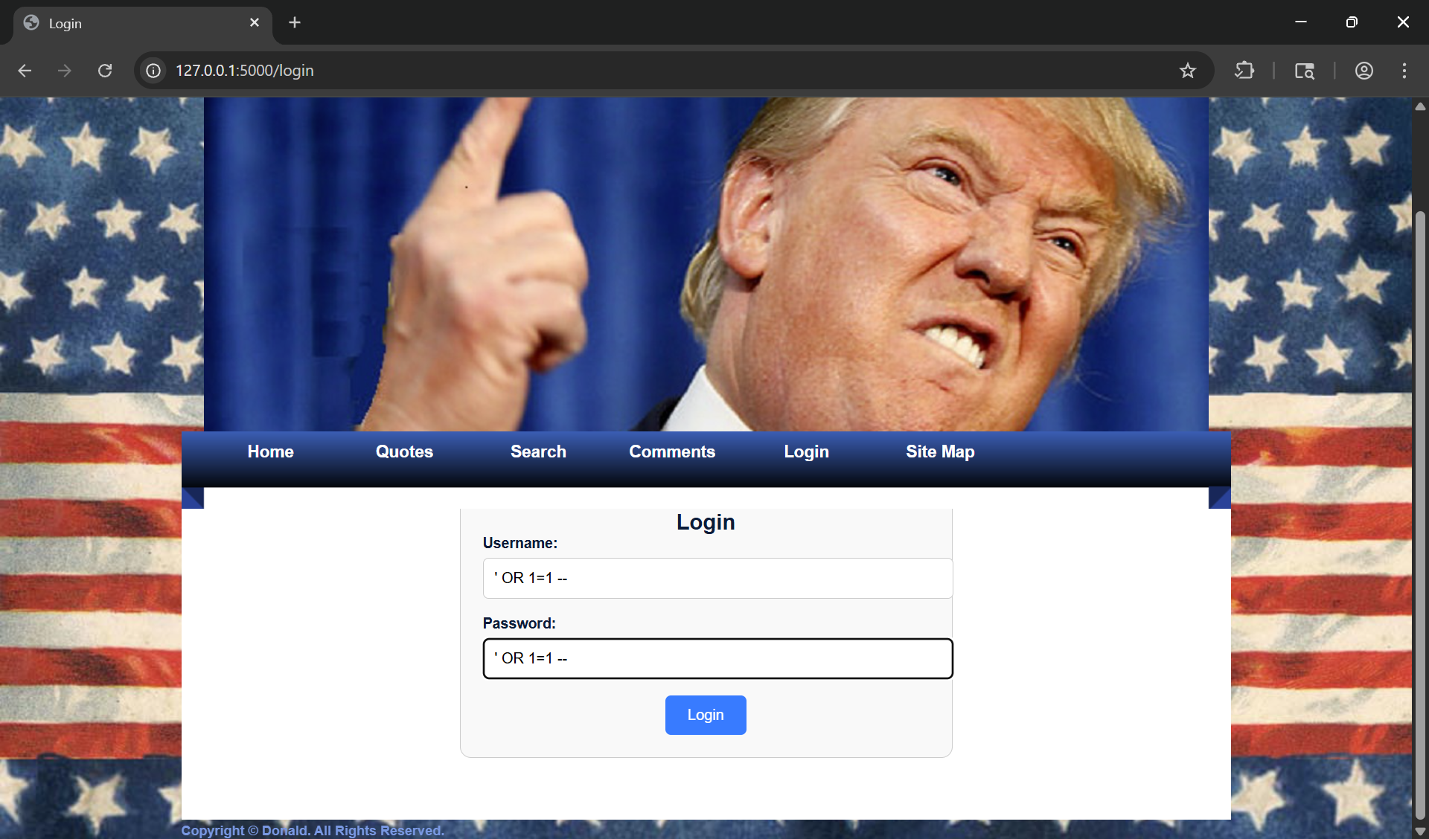

Figure . - SQL injection on the login page.

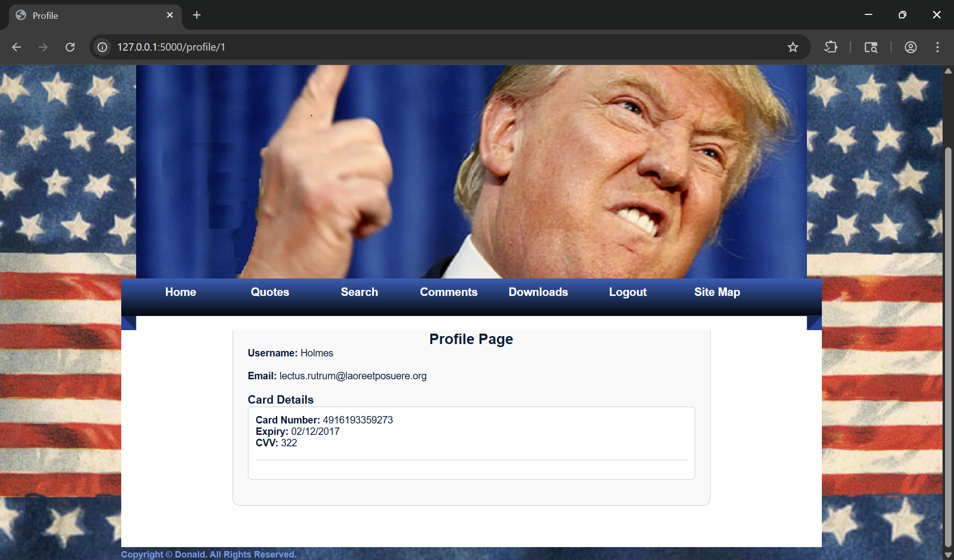

Figure . – Profile accessed through the SQL injection

### Remediation Steps:

Before:



Figure . - Code vulnerable to SQL injections in app.py

After:

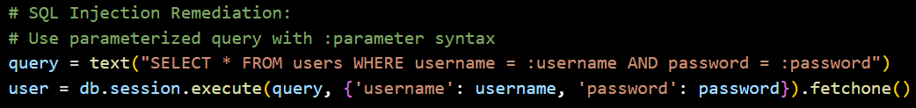

Figure . - Remediation attempt made in app.py

The fixed version uses a parameterized query with placeholders, ‘:username’ and ‘:password’. This separates the data to be inserted and the query itself. This means that the user data entered will be treated as data and not a SQL query.

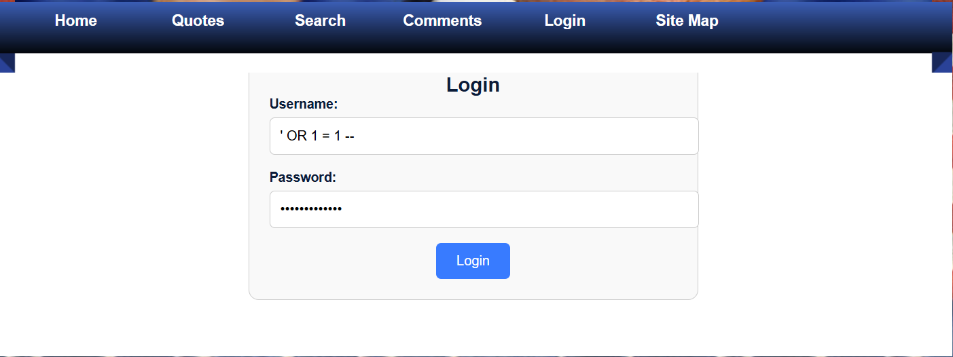

Figure . - SQL injection attempt after remediation

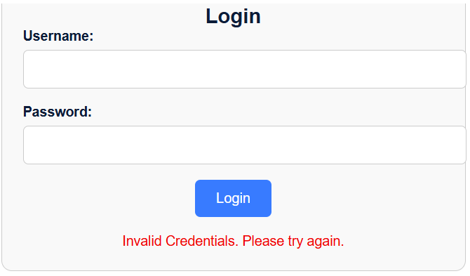

Figure . - Successful remediation attempt

## IDOR

#### Severity:

High

### Impact:

This vulnerability would be devastating as it would give unauthorized users access to other users’ profiles. In this case this would also give unauthorized users access to sensitive information such as credit card information.

### Proof of Concept:

After that I noticed that the URL changed to <http://127.0.0.1:5000/profile/1> so I changed the number and the profile changed to that of another user.

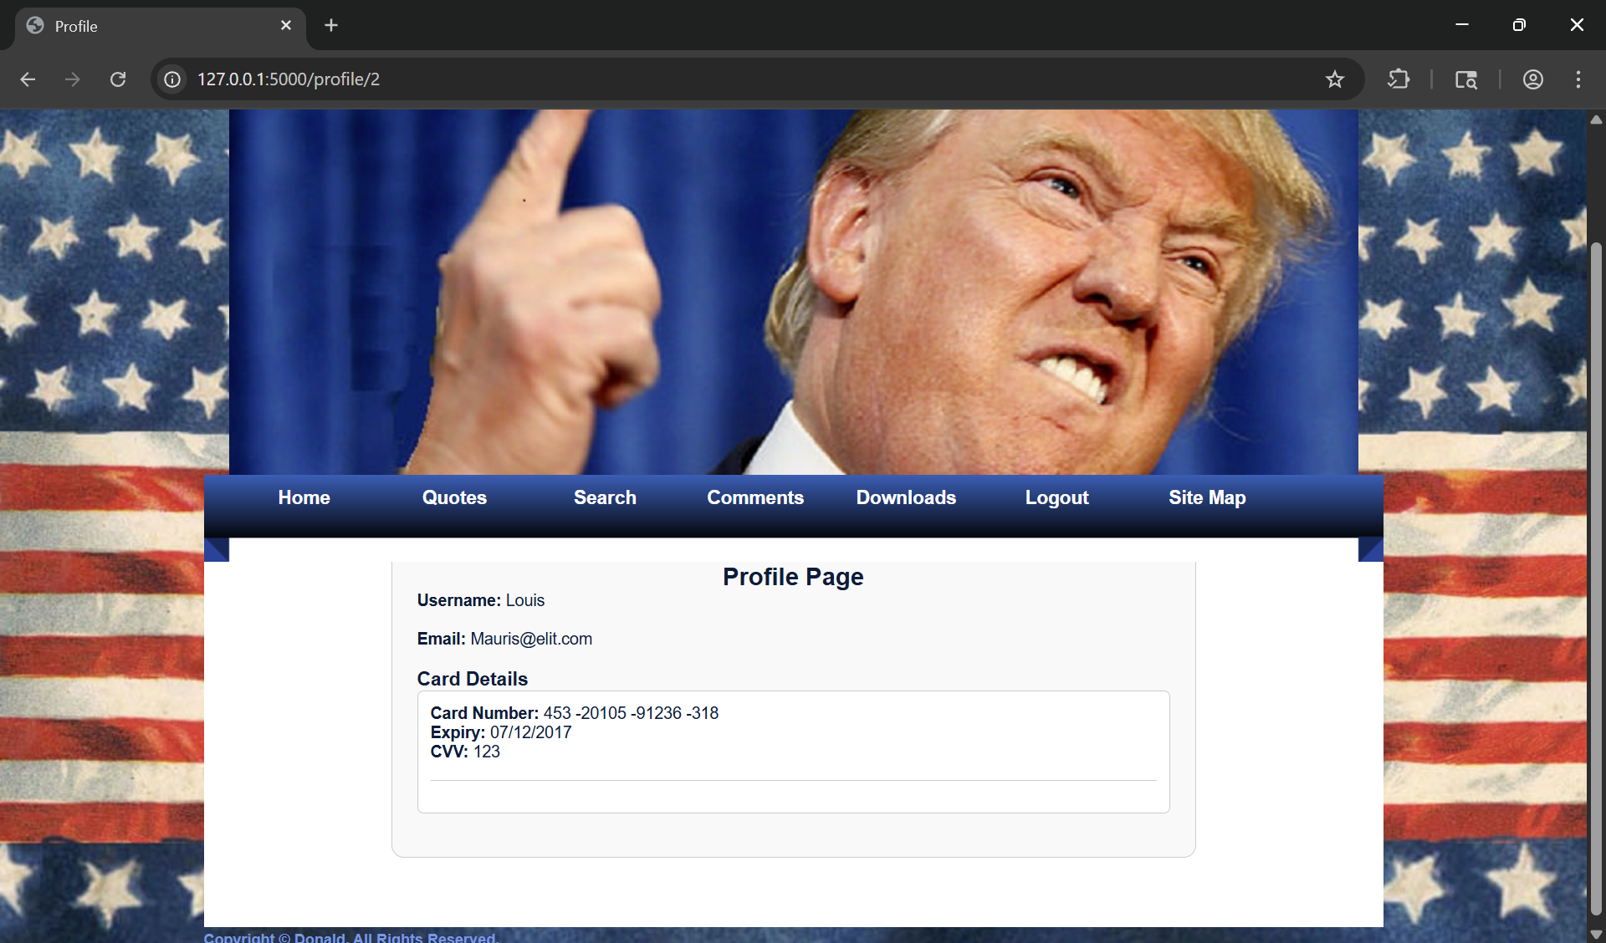

Figure . - IDOR Vulnerability – Accessing profile to that of user id no.2

### Remediation Steps:

The following code was added to ‘app.py’. It checks if the user is logged in by checking if there is a ‘user_id’ value. If the user is not logged in, then the user would get directed back to the login page. If the user_id in session does not match that of the user_id passed to the ‘profile’ function, then the user would get redirected to the profile where the user_id given and the user_id in session would match.

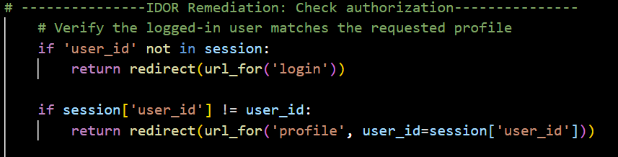

Figure . - IDOR Remediation Code

## Stored XSS

#### Severity:

High

### Impact:

This could induce panic on users as when script is posted it’s stored in the database and when the page refreshes the script runs again. An attacker could put a link to lead authentic users off the platform and onto a malicious website.

### Proof of Concept:

Due to the template (comments.html) using ‘{{ comment.text | safe}}’. This causes it to not rely on Jinja2's auto-escaping which then means anything in a ‘<script>’ tag will get executed as a script.

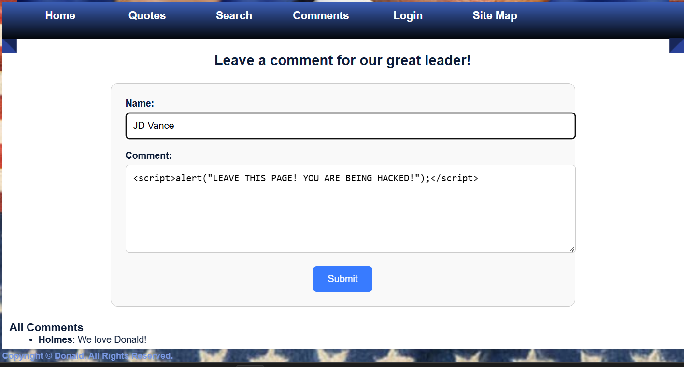

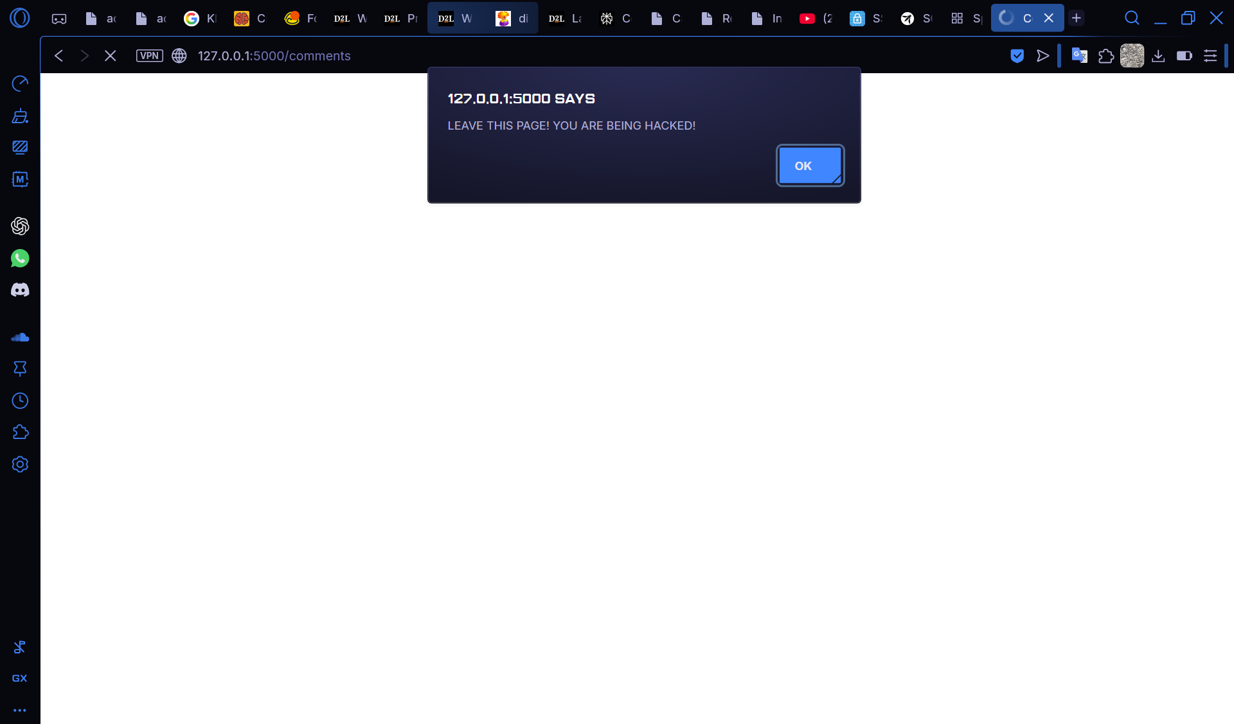

### Remediation Steps:

As mentioned above because it has ‘| safe’ in the template this means that it does not rely on Jinja2's auto-escaping so by removing the ‘| safe’ it means that it can rely on Jinja2's auto-escaping.

Jinja2 auto-escaping works by converting certain characters to other characters.

For example, the original XSS script of:

<div><script>alert('LEAVE THIS PAGE! YOU ARE BEING HACKED!')</script></div>

Becomes:

<div>&lt;script&gt;alert(''LEAVE THIS PAGE! YOU ARE BEING HACKED!')&lt;/script&gt;</div>

This means that what would be a script doesn’t get recognized as a script.

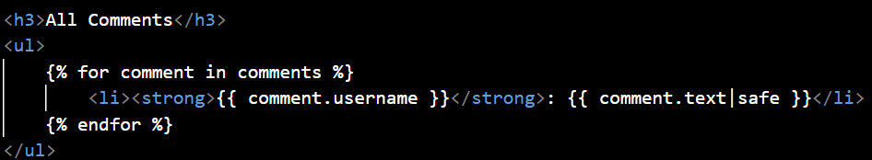

Figure . - comments.html template before remediation

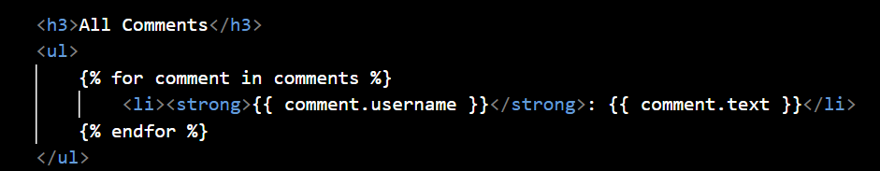

Figure . - comments.html template after remediation

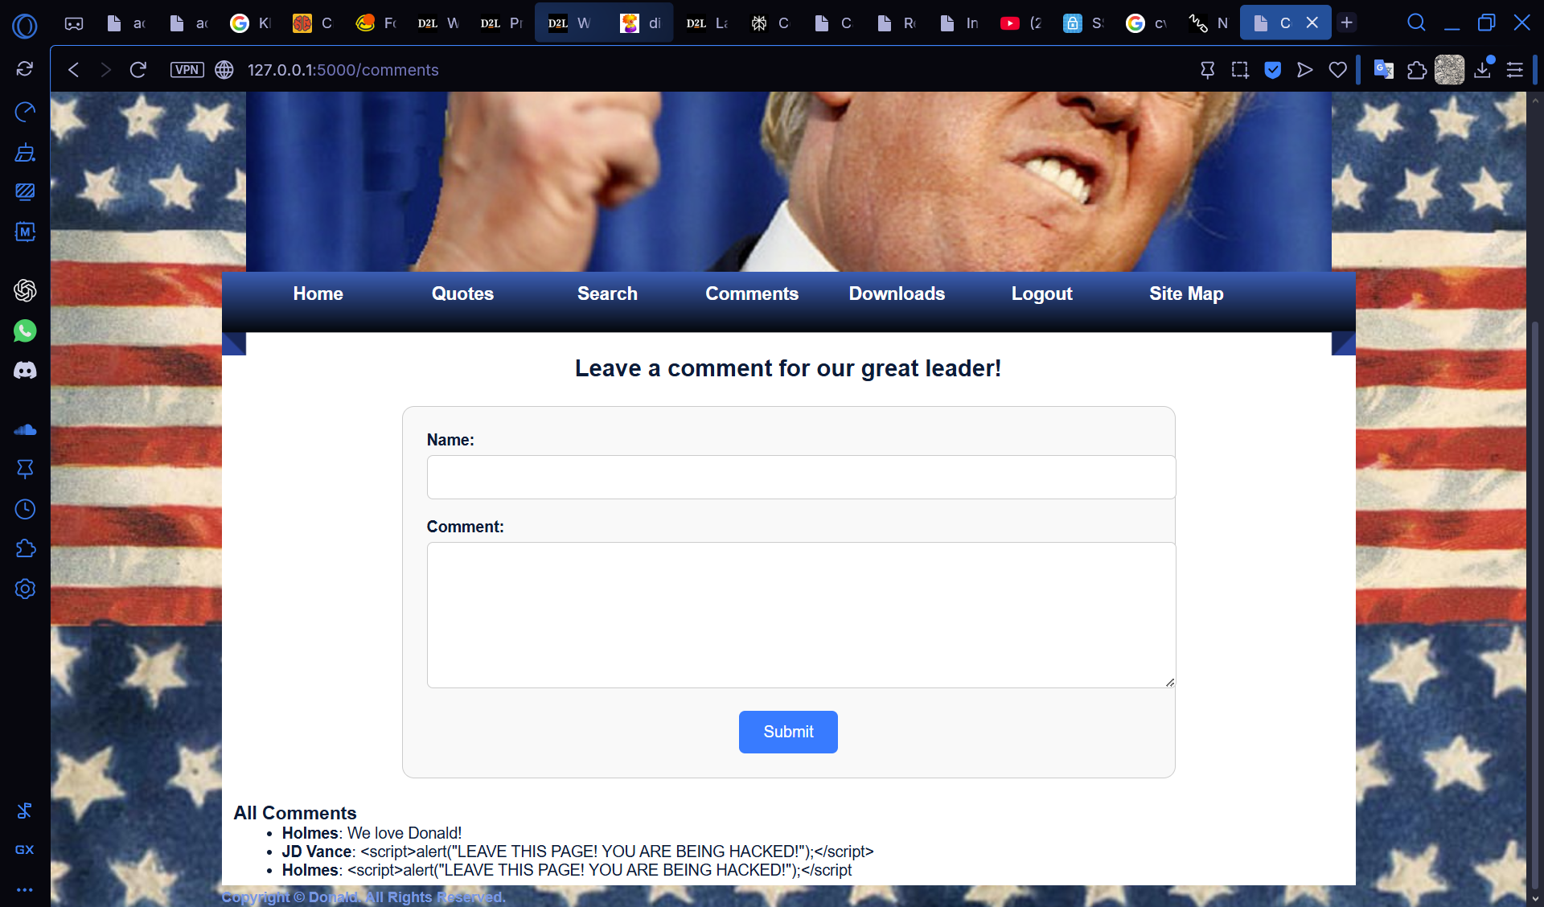

Figure . - Comments webpage after remediation

As seen in Figure 5.3, after remediation the comments section on the website displays the previous XSS script as strings and that it doesn’t get executed. Below is a zoomed in screenshot of the comment section.



Figure . - The comment section after the remediation steps

## Exposure of Sensitive Information

#### Severity:

High

### Impact:

After gaining access to a profile the attacker or an unauthorized user would gain access to the credit card information of the user which the profile belongs to as the sensitive information was shown in plaintext.

### Proof of Concept:

After gaining access to any profile the credit card information of the individual is visible with no hashing or censoring of the sensitive information. One way to deter unauthorized users from stealing that information would be to mask it.



Figure . - Profile page before remediation attempt

### Remediation Steps:

The steps we took to remediate this included creating two python functions to mask the card number and expiry date. This can be seen in app.py source file right above the profile function. Along with that we also removed the CVV from being sent to the template completely as that should not be stored at all. We replaced the field where the CVV would be shown with ‘***’.

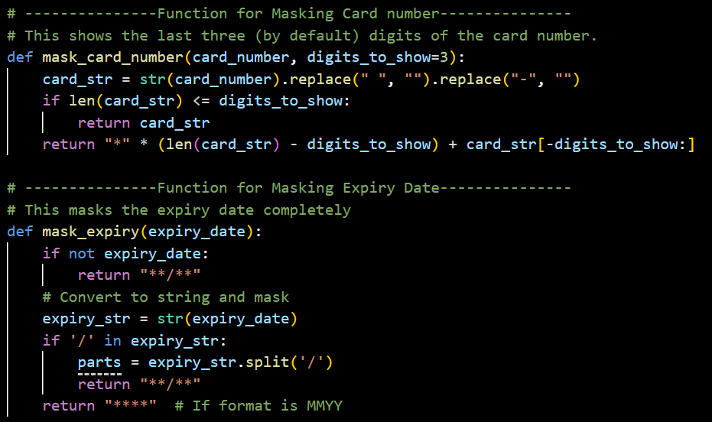

Figure . - Functions to mask card number and expiry

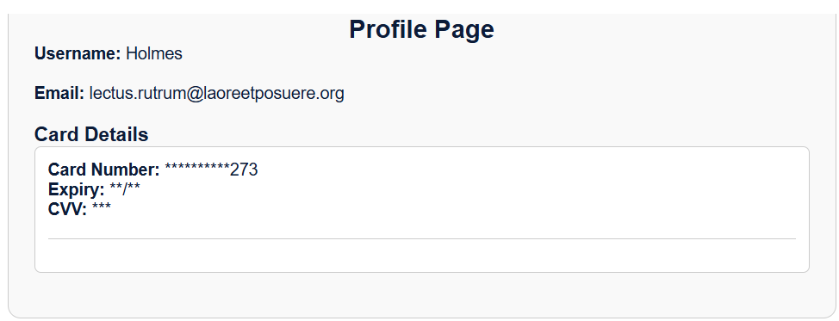

Figure . - Masked card details

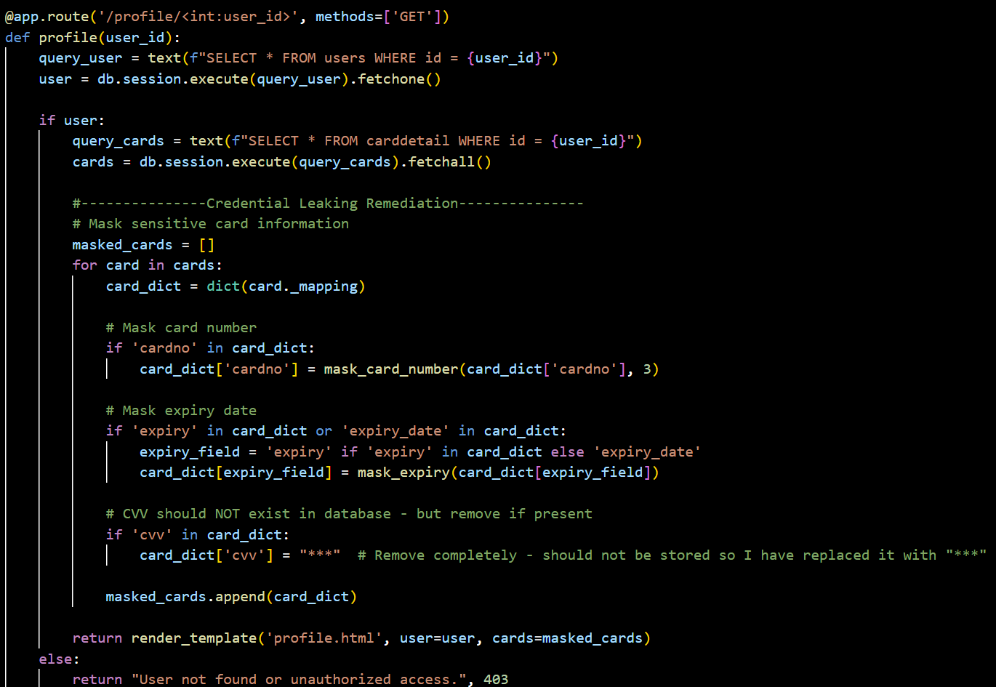

Figure . - Changes made in the app.py source code

## Unmasked Password

#### Severity:

Medium

### Impact:

Unmasked passwords can encourage shoulder surfing and can aid an unauthorized actor in gaining access to one’s account.

### Proof of Concept:

The password field in the login page remains so that it’s not hidden. This can allow the user to be prone to shoulder surfing as the password entered is clearly visible.

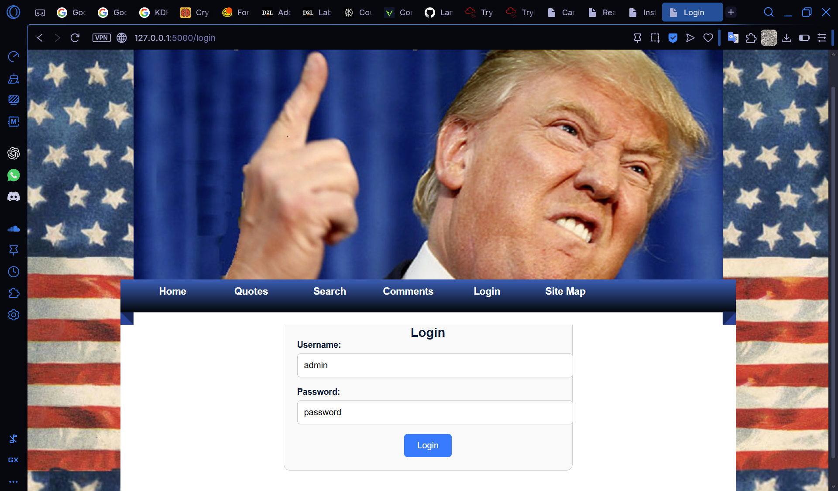

Figure . – Login page before Remediation

### Remediation Steps:

This is a simple fix in the HTML template used. The original had the password field set to a ‘type’ attribute of ‘text’. When the ‘type’ attribute is changed to ‘password’ the entered text is automatically hidden aiding in shoulder surfing prevention. This was introduced since HTML 2.0.

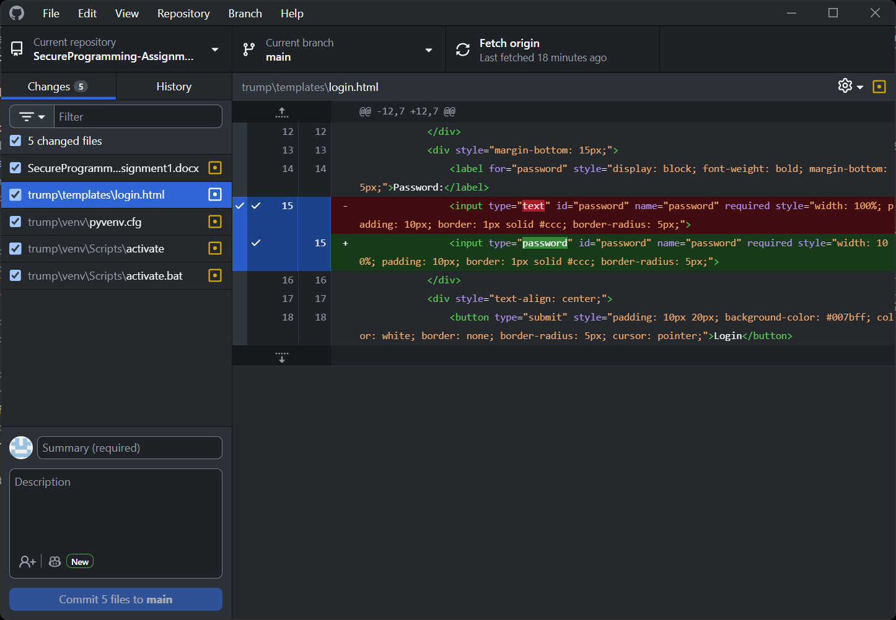

Figure . - Changes in the source code

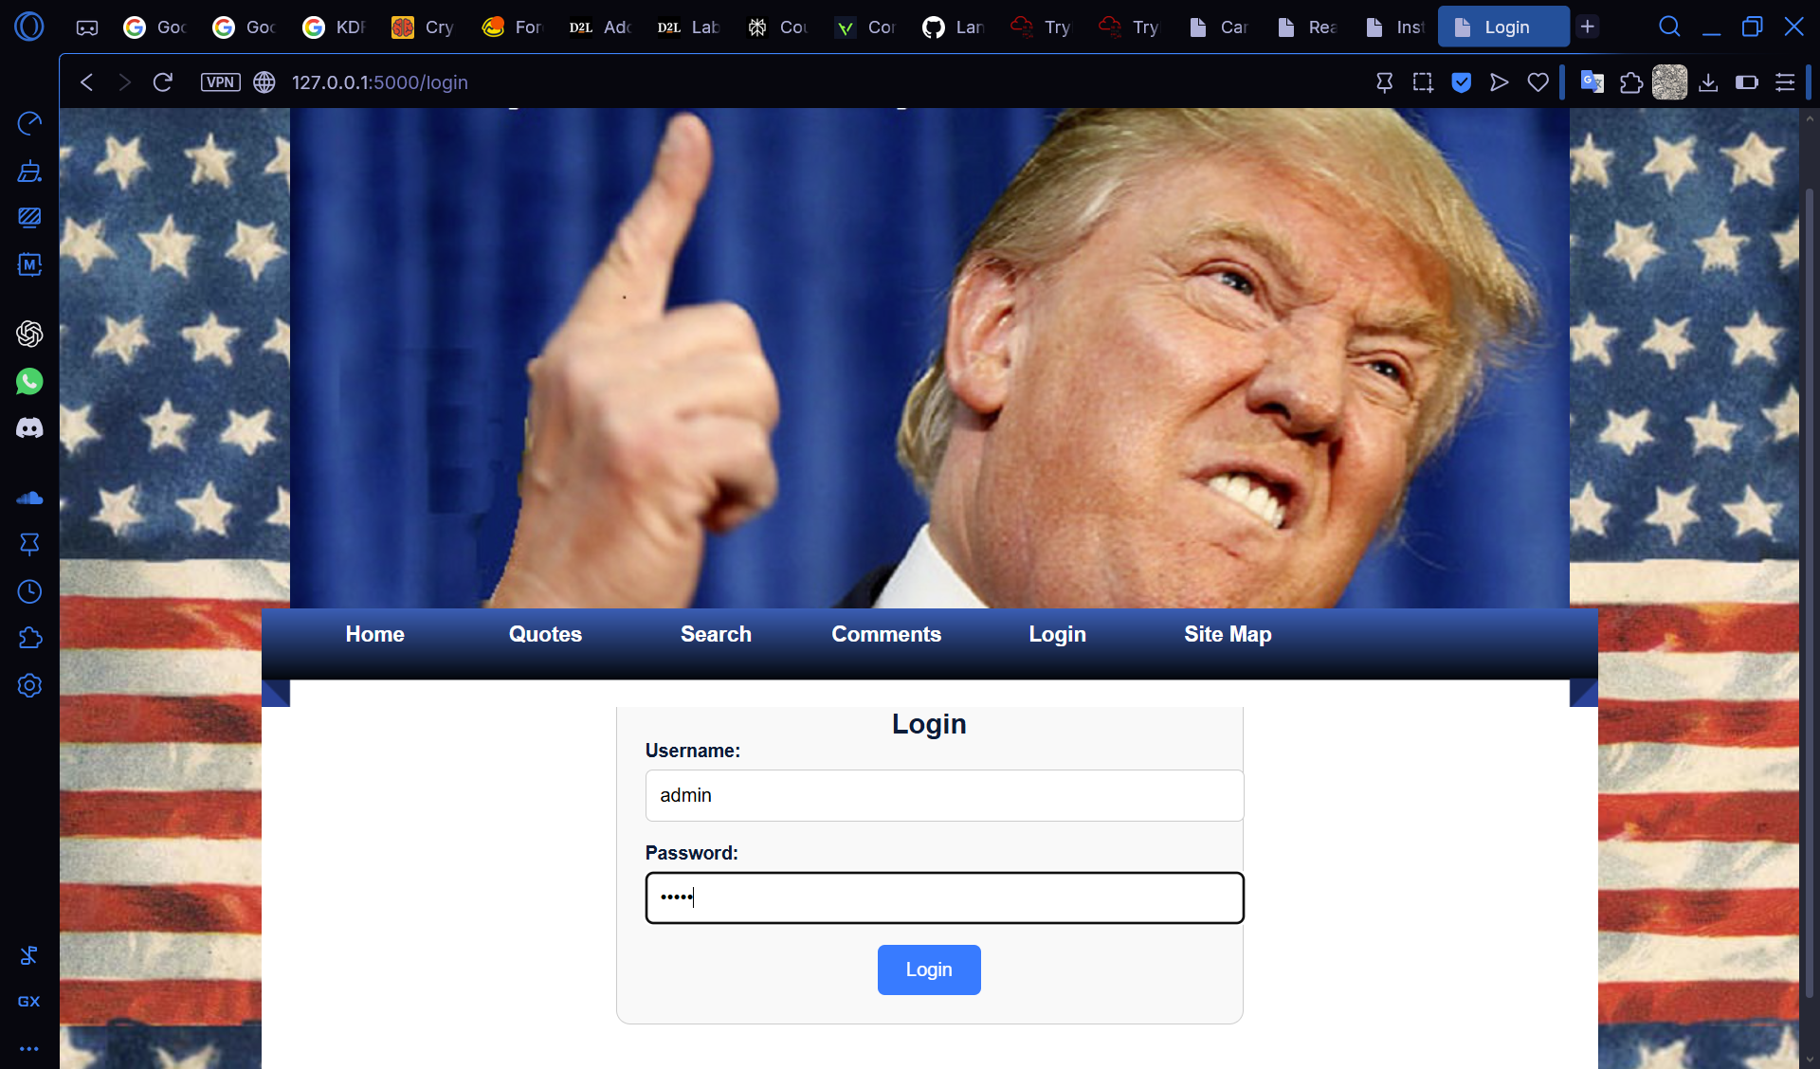

Figure . – Login page after Remediation

## Resource Exhaustion

The comment section of the website does not have a limiter of any sort. This leaves room for malicious individuals to flood the service potentially leading to a denial of service or rapid performance downgrade. This could be taken advantage of through the use of bots or automated tools.

# Conclusion

# Statement of Contribution

## Lan Ngai

* SQL Injection
* IDOR
* Stored XSS
* Exposure of Sensitive Information
* Unmasked Password

## Kai Guy

# References

IDOR:

<https://nvd.nist.gov/vuln/detail/CVE-2024-28320>

<http://cwe.mitre.org/data/definitions/639.html>

SQL Injection:

<https://nvd.nist.gov/vuln/detail/CVE-2023-39344>

<https://cwe.mitre.org/data/definitions/89.html>

Shoulder Surfing:

<https://cwe.mitre.org/data/definitions/549.html>

Credential Leakage:

<https://cwe.mitre.org/data/definitions/200.html>

Stored XSS:

<https://cwe.mitre.org/data/definitions/79.html>